Project Design Phase-I Solution Architecture

|  |  |
| --- | --- |
| Date | 28 September 2022 |
| Team ID | PNT2022TMID24784 |
| Project Name | Signs with Smart Connectivity for Better Road Safety |
| Maximum marks | 4 Marks |

Signs with Smart Connectivity for Better Road Safety:

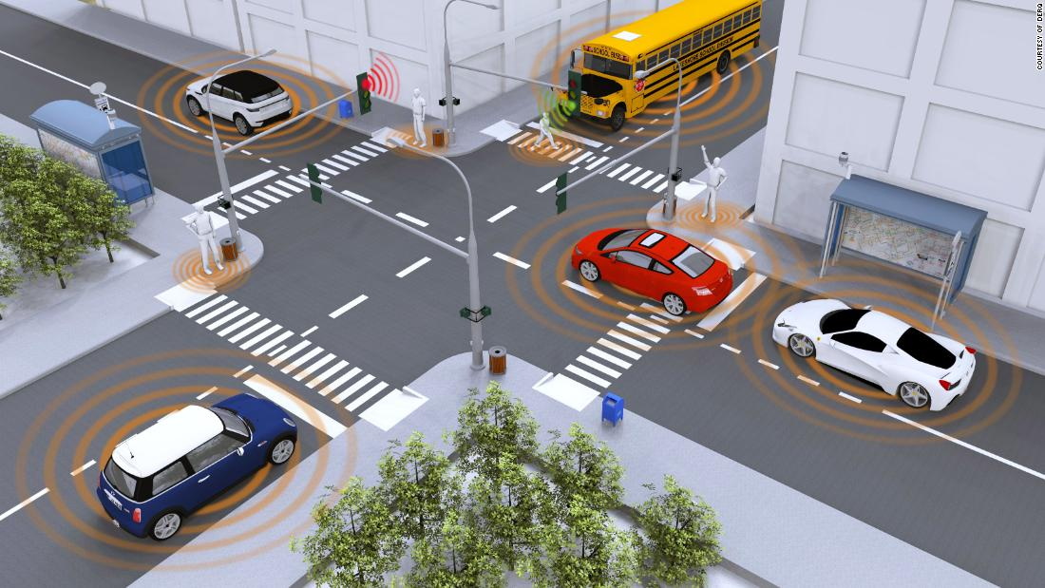

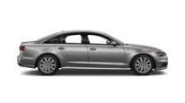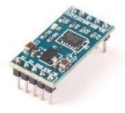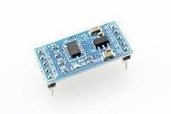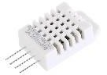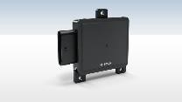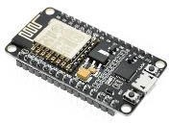

Monitors

the road condition

Accelerometer sensor

Vehicle

ESP32

GPS Sensor

IBM Cloud

Storage

Gravity Sensor

Weather

condition

DHT22

vehicle

detection

Driver

Wi-Fi

RadarSensor